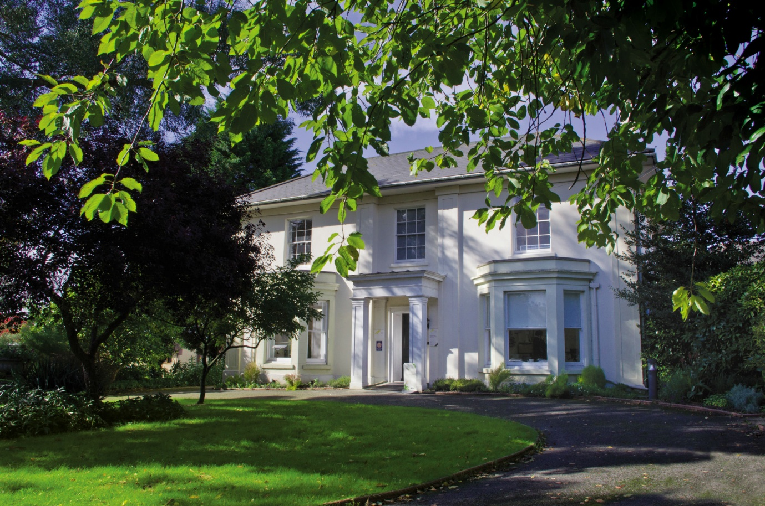

Access Statement

Thelma Hulbert Gallery (THG)
This statement provides an overview of the Gallery's policies regarding access to the collection and the Gallery, including our commitment to equal opportunities in employment.

Introduction

THG (Thelma Hulbert Gallery) is located in Elmfield House (a Grade II listed building) in Honiton. The gallery houses a permanent display of a collection of paintings by artist Thelma Hulbert and a changing programme of contemporary art and craft exhibitions. The gallery is open Tuesday to Saturday from 10am – 5pm and admission is free.

Information regarding how to get to the gallery including links to local transport is located in the ‘Visit/Accessibility’ section of their website and in the gallery’s exhibition programme which is available on request.

1. Statement of general principles
THG (Thelma Hulbert Gallery) is committed to the widest possible access to both the permanent collection of artwork and the temporary exhibitions, which it houses and displays. The artworks are accessible to everyone regardless of education, income, residence, or personal circumstances.
The Gallery welcomes visitors with disabilities. The Gallery's aim is to make physical access to the collection and the exhibitions as easy as possible for all and to allow everyone to enjoy and study the artworks in as many ways as possible.
The gallery is owned by East Devon District Council and as a service provider and equal opportunities employer, it aims to comply with the provisions of the Equalities Act 2010 and with the amendments made since.

2. Access to the Collection/Gallery

Getting to the gallery

By Foot/Bike - THG is easily accessible from Honiton’s town centre. It is a 5 minute walk from the High Street. From the High Street, turn into Dowell Street and take the first turning on the right. The Gallery (housed in a white Georgian building) is immediately to your left.

By Car – From the A30 take the turning to Honiton and follow signs to town centre. On Honiton High Street, take the turning into Dowell Street in front of the police station. Take the first right turn off Dowell Street leading to two pay & display car parks and a disabled parking bay in front of THG.

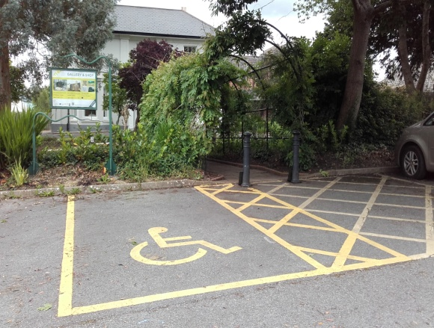 Disabled parking bay leading to THG

By Public Transport - THG is easily accessible by bus and rail. Contact www.journeydevon.info for up to date information on services to Honiton.
Honiton railway station is approx. 10 minute walk from THG. For buses stopping on the High Street it is approx. 5 minute walk to the gallery.

TRIP community transport - TRIP provide a disabled accessible vehicle service for the whole community, serving the Honiton area. The Honiton & District Ring & Ride is a fully accessible door to door bus service for wheel chair users covering the town and surrounding areas, providing transport for shopping & trips out.

Physical access
The Gallery seeks to provide all visitors with equal access to the building, making alternative provision where necessary, within the constraints of a Grade II Listed Building. It ensures that current and future building projects provide appropriate physical access for all visitors. Expert advice is sought wherever necessary.

Access to our building
The Gallery’s aim is to make all visitors welcome.
Bikes - bike racks are adjacent to the gallery for visitors arriving on bikes
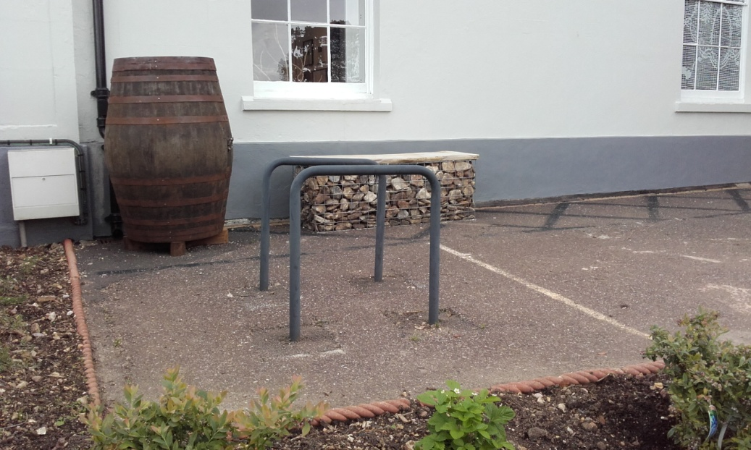 Bike racks
Signage- large signs have been erected in the car parks and at the front of the building to signpost visitors to the gallery.
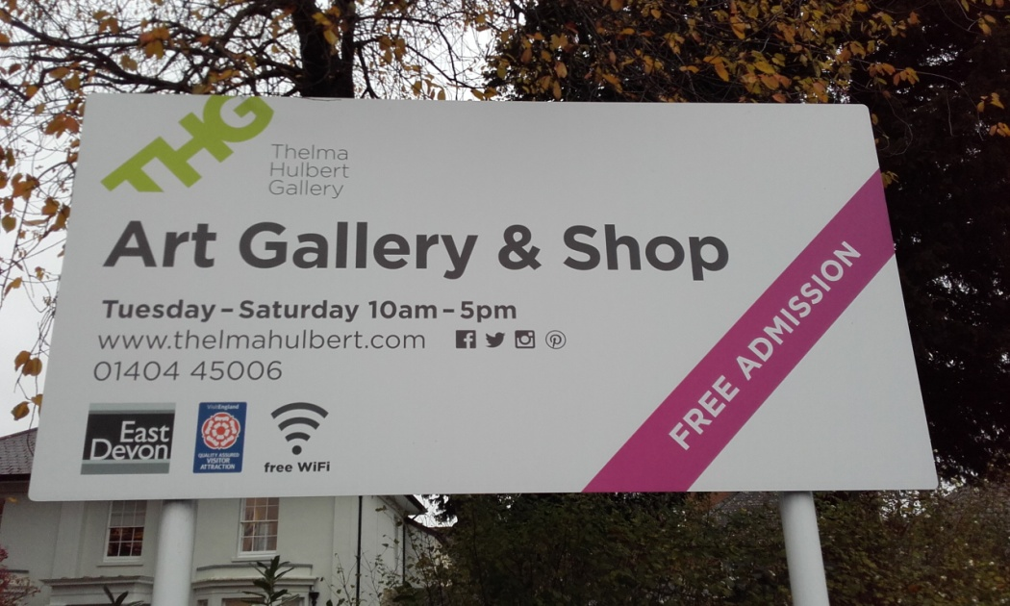 Sign in car park in front of gallery
Paths to building- a flat wide path (paving then tarmac) leads from the car park to the entrance. The area is regularly maintained to remove leaves and overgrown shrubs to ensure easy access. Self-activating outdoor lights provide extra light to this path in winter months.
There is a low wheelchair and pushchair-friendly ramp up to the front entrance. The front door is 100cm wide.
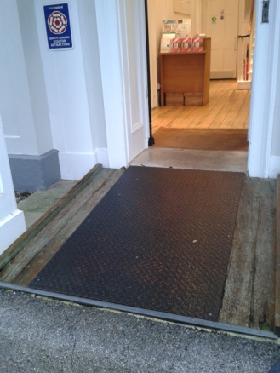 Ramp to entrance
Within the gallery - the building has been re-developed to ensure physical access is improved for everyone. All areas are well lit with spotlights and ceiling lights. The downstairs area has wooden floors and both the stairs and upstairs galleries have short-pile carpets. A wheelchair is available for use and there is seating is in all rooms and the garden.
Ground floor layout– entrance hall leading to main gallery, accessible toilets, shop and refreshments area (all one level)
To aid visitors with visual impairments, high visibility white strips have been added to the stair edges to improve visibility. There are 20 steps to the upstairs spaces.
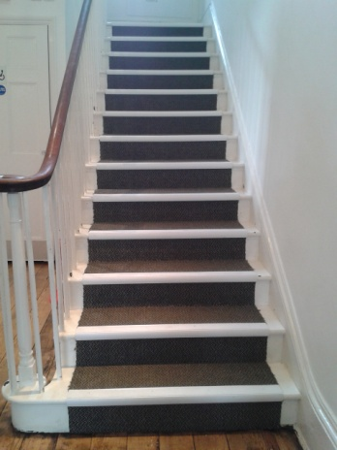 Steps to upper floor
Lift - there is also a wide, wheelchair and push chair friendly platform lift (with tactile buttons, non-slip floor and permanent handrails) giving access to upper floor.
Upper Floor – level access to Project Space, Learning Room and Thelma Hulbert Room and standard toilets.
Baby-changing - we have baby-changing facilities to make it easier for those with young children and wide access for push chairs. There is a quiet area for breastfeeding and feeding bottles can be warmed on request.
Accessible toilets - there are accessible toilets on the ground floor adjacent to the main gallery and two toilets on the upstairs floor.
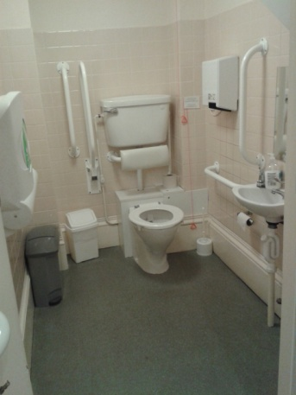 Accessible toilets
Refreshments area / gift shop - there is free WIFI available at THG with a pass code. The gift shop is located on the ground level and there is sufficient space for wheelchair access, however assistance is available on request. The refreshments area has moveable chairs and tables to allow wheelchairs to manoeuvre. We offer hot and cold drinks and biscuits - please ask if you have any dietary requirements.
Assistance dogs are welcome. Water bowls are available on request.

Access in our garden - the accessible new gallery garden is immediately in front of the gallery. It includes wheel chair friendly hoggin paths around the flower beds, raised vegetable beds, 60cm high seating (see below image) and a sensory herb garden.

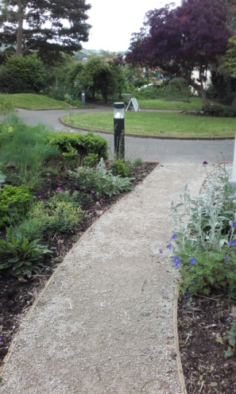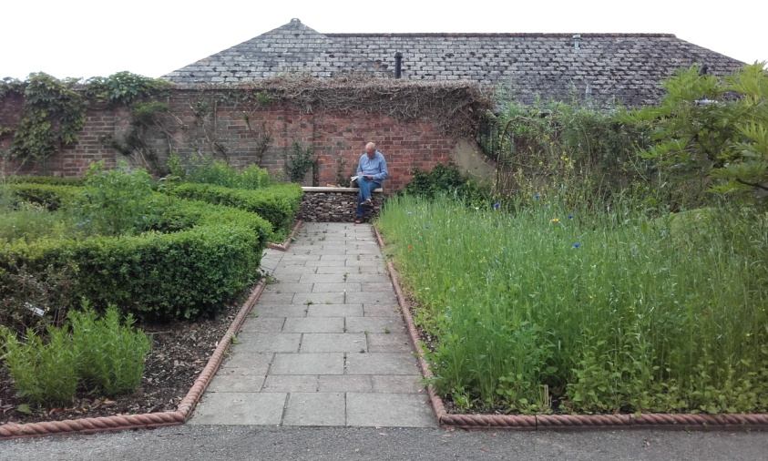

Garden paths
New safe gates have been installed at the garden entrance as a barrier to the road to ensure it is safe for children and adults with Dementia.
We have relocated the disabled parking bay to the garden entrance to ensure the garden itself is as vehicle-free as possible.

Learning about the Collection
Accessibility is not just about making a space physically accessible. As well as eliminating material obstacles for visitors, the Gallery strives to be relevant, engaging and accessible to marginalised groups through exhibitions and activities – considering their needs.
The Gallery encourages and enables the widest possible audience to engage with the artworks. It seeks ways to improve and extend access to information and research. The Gallery continues to consult people with access needs, specialists and other galleries, on the best and most practical ways of improving intellectual access. The Gallery staff and volunteers have undertaken Dementia Friendly training to consider the needs of those living with dementia and their carers and the Gallery is part of a wider initiative to make Honiton dementia friendly.
Website : The Gallery website www.thelmahulbert.com meets W3c/WAI international standards. It is regularly updated and is fully responsive for mobiles and tablets. It has been made as user-friendly as possible e.g. each image has alt text to describe the image and there is button on the home page to enable users with visual impairments to switch to a high contrast version. Accessibility to the Gallery is highlighted under the ’Visit us’ tab including :
  - Google maps of the Gallery
  - Transport information – bus and train links
  - TRIP community transport
  - Disability access and disabled parking

The gallery is closed to the public on Mondays. We can reserve this time for groups who require a quieter environment to visit the gallery. Please contact us to discuss.

Safety in the building
The Gallery takes account of the needs of visitors with disabilities in all safety procedures. It is the policy of the Gallery to enable all occupants of the building to be evacuated at the same time in an emergency.
The Gallery also provides all staff trained in first-aid and fire safety with training in the evacuation of people with disabilities and other emergency procedures. The fire alarm is checked weekly.

Information and signage
The Gallery strives to provide information in forms that are accessible to all visitors and to cater for most needs. We offer information e.g exhibitions brochure in alternative large print formats and Braille on request and review this regularly. Signage is designed and situated to be as legible as possible. We offer a magnifying glass available on request to help reading and audio loops for Gallery talks.
The Gallery undertakes to review regularly its methods of communication and to adopt best practice in this area.

3. Employment and training
The Gallery, as part of East Devon District Council, aims to ensure that its employment practices do not discriminate against people with disabilities and maintains a system for monitoring and reviewing procedures.
The Gallery provides disability awareness training for staff and volunteers and maintains ongoing training in this area. The staff have all undertaken First Aid training and diversity, equality and discrimination training. The Education Officer has undertaken Deaf awareness and Child & Vulnerable Adult Protection Policy training.
The Staff meet regularly to discuss improvements to the Gallery's provision and to agree upon recommendations for further action. Our staff and volunteers have undertaken Dementia training to become Dementia Friends.
A copy of the statement is available to all members of the public on request. We welcome any feedback or suggestions regarding your visit or this Access Statement to improve our visitor experience. Please address your suggestions to:
Thelma Hulbert Gallery, Elmfield House, Dowell St, Honiton EX14 1LX / Tel : 01404 45006 / Email : info@thelmahulbert.com
November 2016

